Exploring Nairobi using Google Earth

1. Open Google Earth (usually by double clicking on an icon that looks like this).

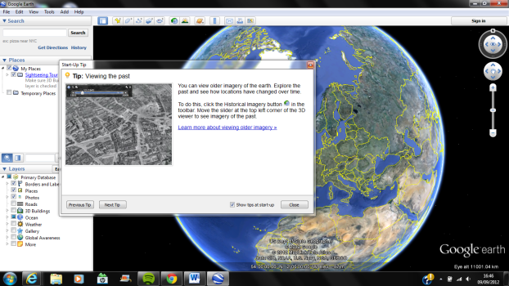2. Close any opening messages.

3. Click on the search bar and search ‘Mukuru Slum Nairobi’.

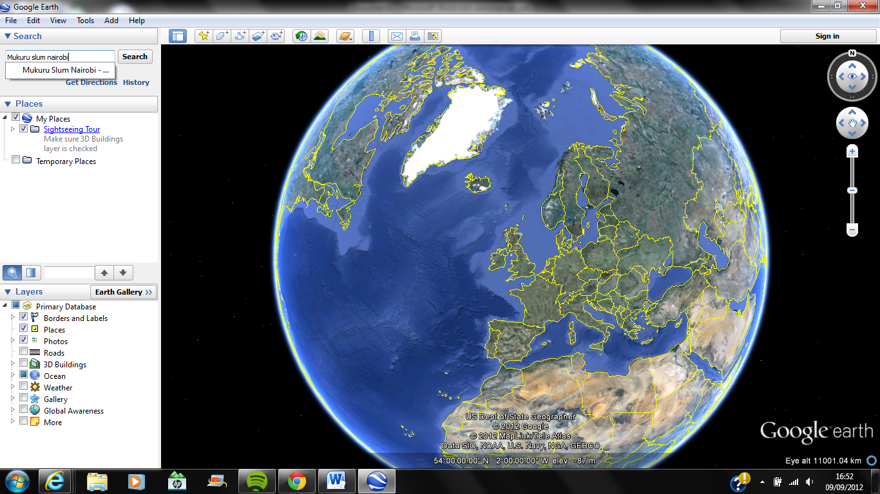

4. Use the zoom control on the right-hand side to zoom in for a closer view.

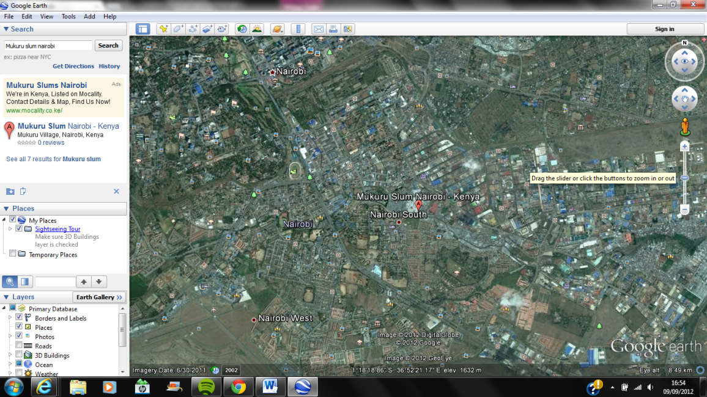

5. Close the search options as shown below to clear the 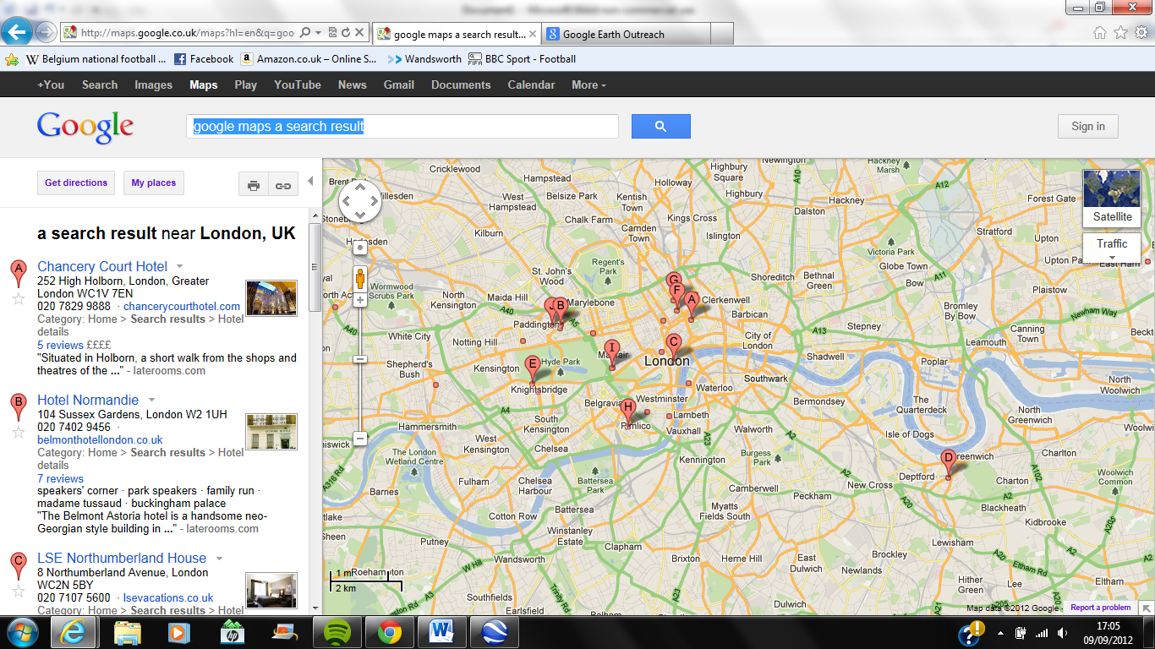 sign from your map.

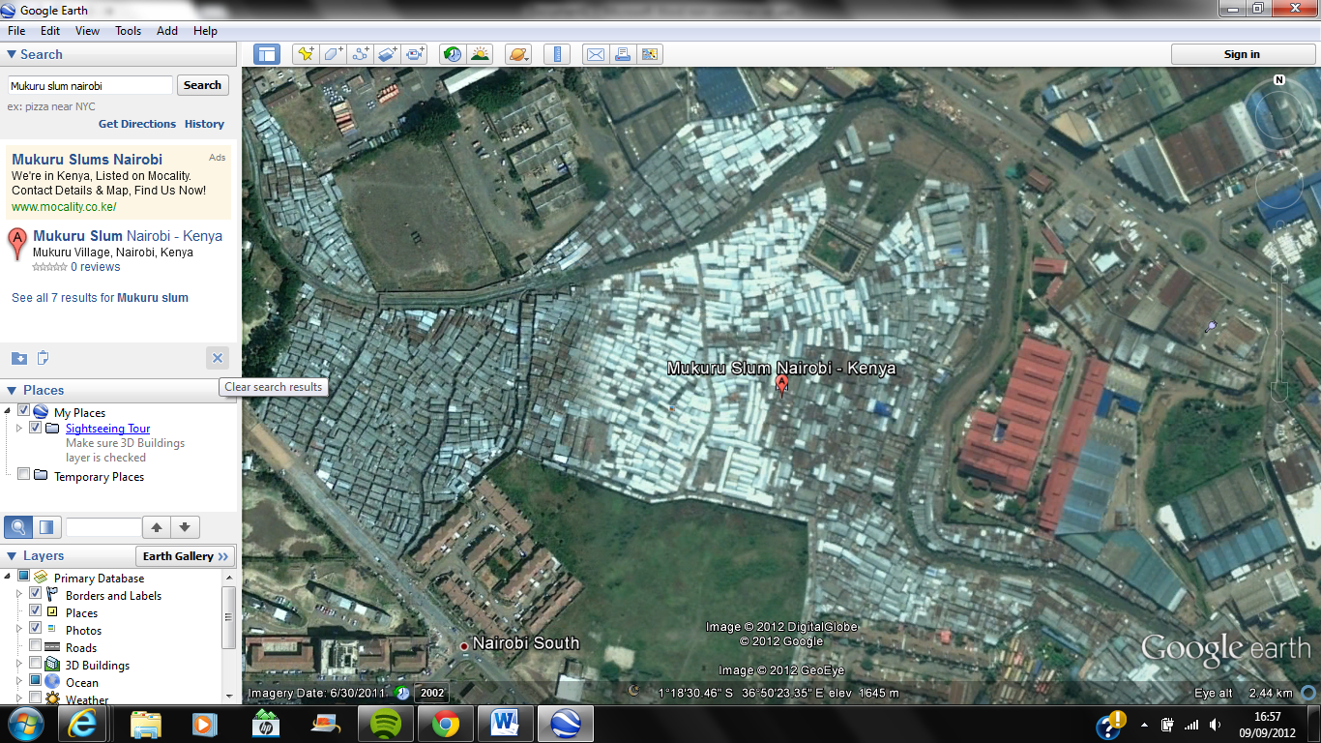

6. Click on the yellow pin in the top-left corner. Ensure the pin is placed roughly in the centre of Mukuru.

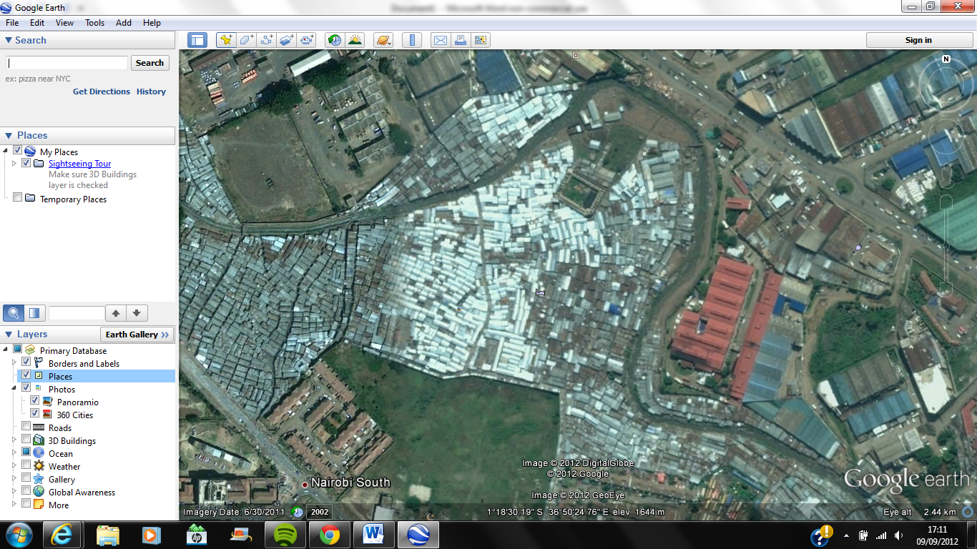

7. In the box that comes up, type ‘Mukuru’into the name bar and paste the URL for the image (shown below) into the *Image URL* space after clicking *Add Image,* then click the top *OK*. Then click the bottom *OK*.

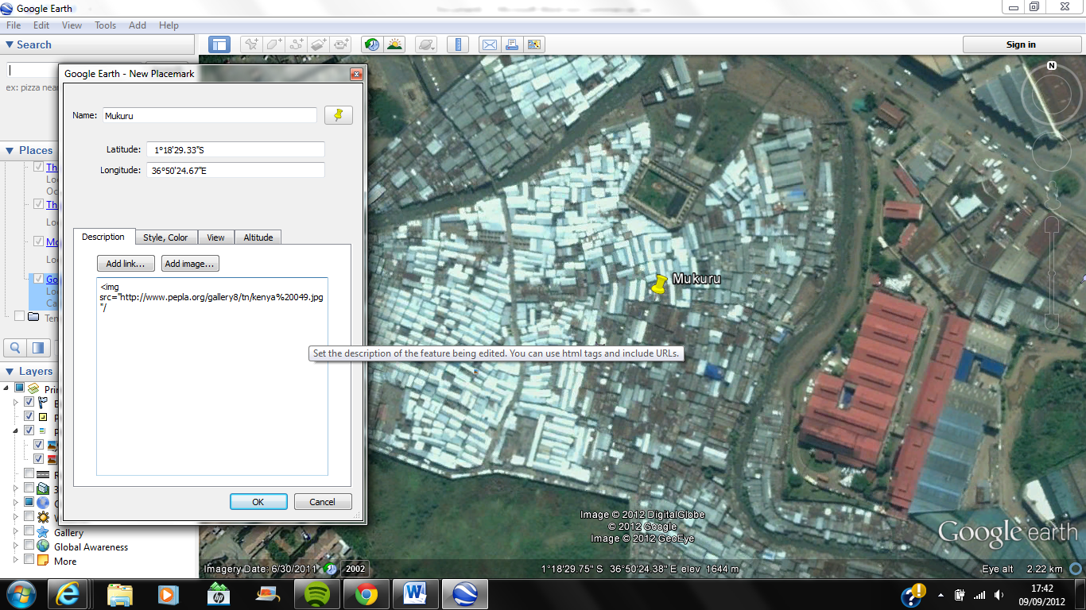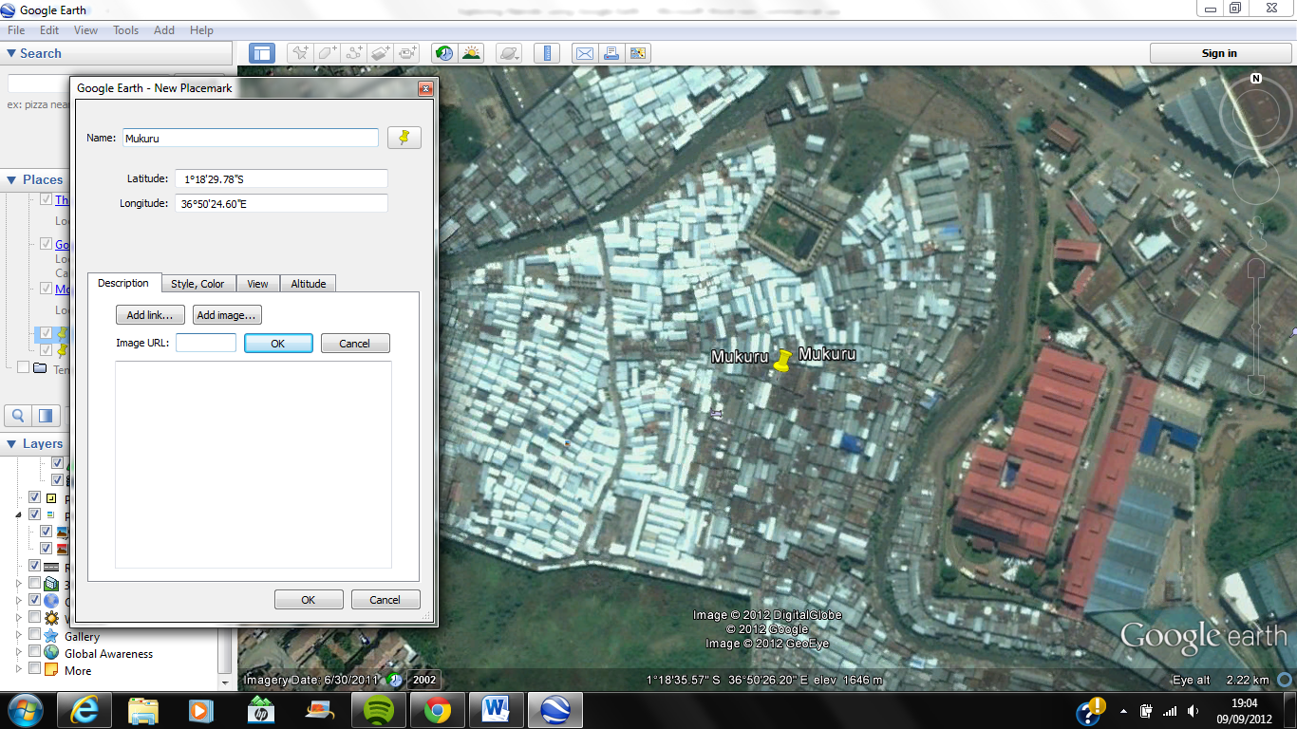Mukuru: www.pepla.org/gallery8/tn/kenya%20049.jpg

Top ***OK***

Bottom ***OK***

8. Check the image by clicking on the pin. It should loo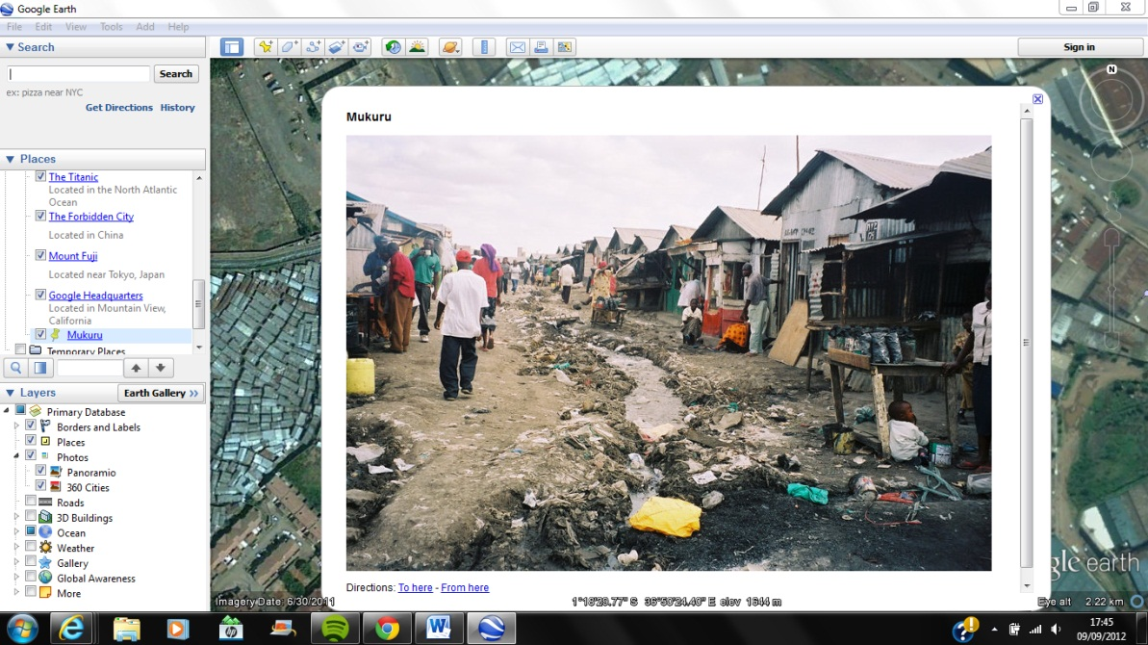k like this:

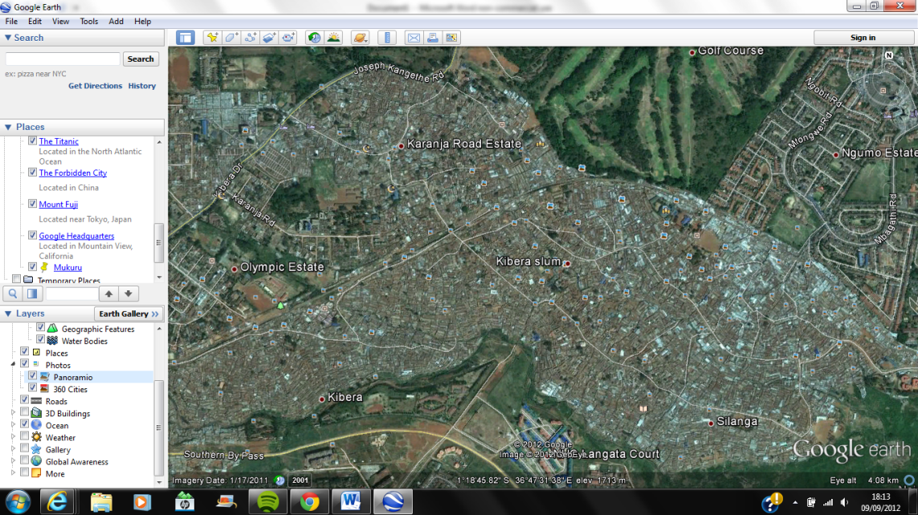9. Now find the Kibera slum. Either by zooming out and scrolling west until you find a large slum labelled Kibera Slum, or just by searching ‘Kibera Slum’.

10. Add another pin, label it Kibera, copy and paste the URL from the link in blue below this paragraph into the ‘add image’ section and click the two *OK*s. Click on the pin and it should look like this:

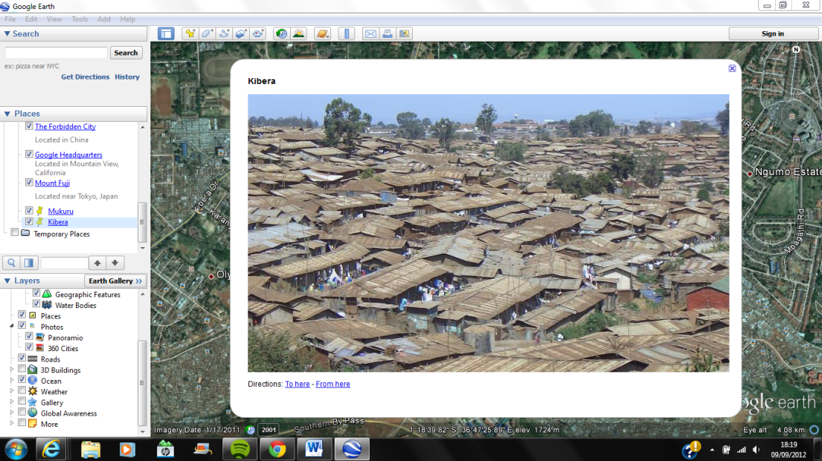Kibera: [www.housing.go.ke/wp-content/uploads/2011/07/kibera_slums.jpg](http://www.housing.go.ke/wp-content/uploads/2011/07/kibera_slums.jpg)

11. Now do the same for these other Nairobi locations using the photo URLs below.

**Kambi moto, Nairobi** (part of the housing project in Huruma)

<http://2.bp.blogspot.com/-kO4kUBLOTtE/TgOi0tQ2zuI/AAAAAAAAACE/V2k0dZHJmx4/s1600/kambimoto%2Bpano%2Bedit%2B1.jpg>

**Kileleshwa, Nairobi** (an area of executive housing)

<http://www.mydeals.co.ke/pics/housing/5134-one-house-mydeals.jpg>

**Victoria Towers, Upper Hill, Nairobi** (part of the new business district)

<http://www.egmgem.com/content/main/Victoria%20Towers%20Upper%20Hill%20Nairobi%20Kenya%20Building%20Eric%20Gitonga%20Photography%20Creaive%20Commons%20Non-Commercial.jpg>

**Nairobi Central**

[www.fig.net/news/news_2007/isk_april_2007/nairobi_600.jpg](http://www.fig.net/news/news_2007/isk_april_2007/nairobi_600.jpg)

**For more help with Google Earth use this link:**

[www.google.com/earth/outreach/tutorials/annotate.html](http://www.google.com/earth/outreach/tutorials/annotate.html)

**Open Street Map**

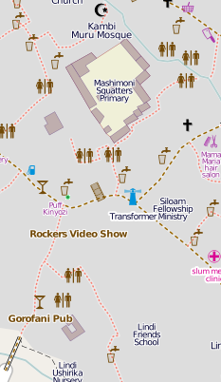You can also explore Nairobi through the website [www.openstreetmap.org](http://www.openstreetmap.org) by typing, for example ‘Mukuru, Nairobi’ into the search bar. Find out more about how the slums were mapped from the Map Kibera website at [www.mapkibera.org](http://www.mapkibera.org)

This is a small section from the Open Street Map of the slum district in Nairobi. What kind of detail does it show which could be helpful when researching the slum settlements?

What is the link between mapping projects like Map Kibera and slum improvements?

Use this quote to discuss why mapping is important   
*‘The problem: If you don't exist on paper, you don't exist at all.’*